Turmoil and Unrest in France

In 1774, Louis XVI, a 19-year-old prince, came to the throne as the King of France. His 18-year-old wife was named Marie Antoinette. King Louis XVI inherited a massive amount of debt from his predecessors. He further increased the debt of the French Government by supporting the American Revolution in its fight against France’s bitter rival, Great Britain. King Louis XVI became desperate to raise funds to pay off the debts of France.

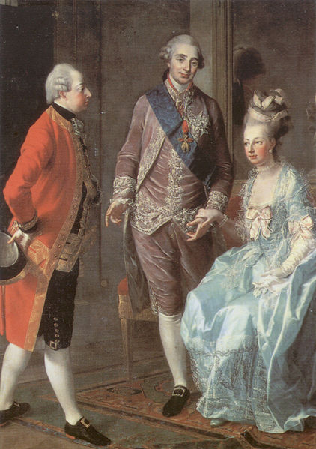In order to pay off these debts, he decided that he would tax the first and second estates, which had always been exempt from paying taxes before. These estates refused to pay the new taxes.

In 1789, King Louis XVI summoned a group known as the Estates-General to meet in Versailles to discuss the matter of taxes. The Estates-General was a body of people representing each of the three social estates in France. They had not been called together since 1610.

King Louis XVI hoped that by calling them together they could solve the problems of debt facing the nation. The Estates-General had other plans, however. They wanted to use the meeting to take power from the King and address the social ills that they felt were plaguing them.

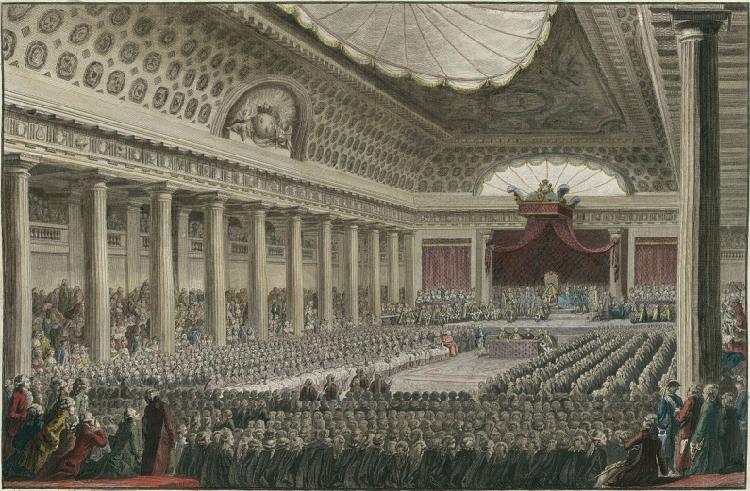A French Constitution

Members of the Estates-General representing the third estate outnumbered representatives from both the first and second estates combined. If each representative were to be given one vote, the third estate would have more votes and would have been able to get their will passed. In order to insure this did not happen, King Louis XVI locked representatives of the third estate out of the meetings.

Outraged, they met at a nearby indoor tennis court where they gave themselves the name of The National Assembly. Here, representatives took an oath that they would not leave until they had written a new constitution for France.

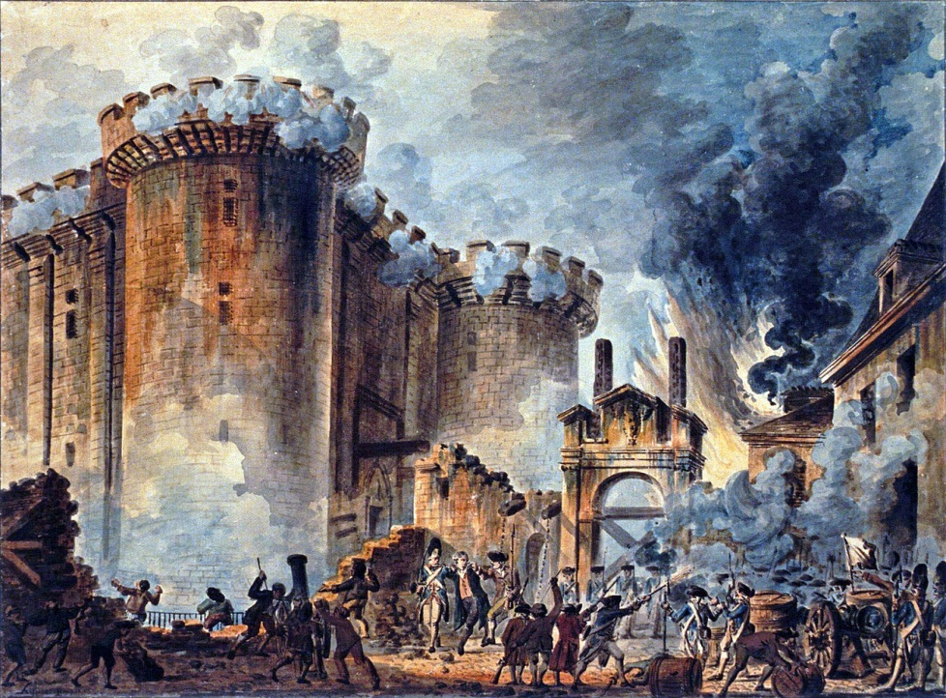King Louis XVI worried about the form this constitution would take if it were to be written strictly by members of the third estate. He ordered representatives from the first and second estates to join the National Assembly.

**A Revolution Begins**

As the National Assembly met to write a new constitution, their debates often spilled out into the streets of Paris. Soon, everyone in the capital was debating the social ills of France, and what form a new government should take.

Fearing the sentiment of revolution that was quickly expanding throughout the capital, King Louis XVI placed troops throughout the capital city as well as around the palace.

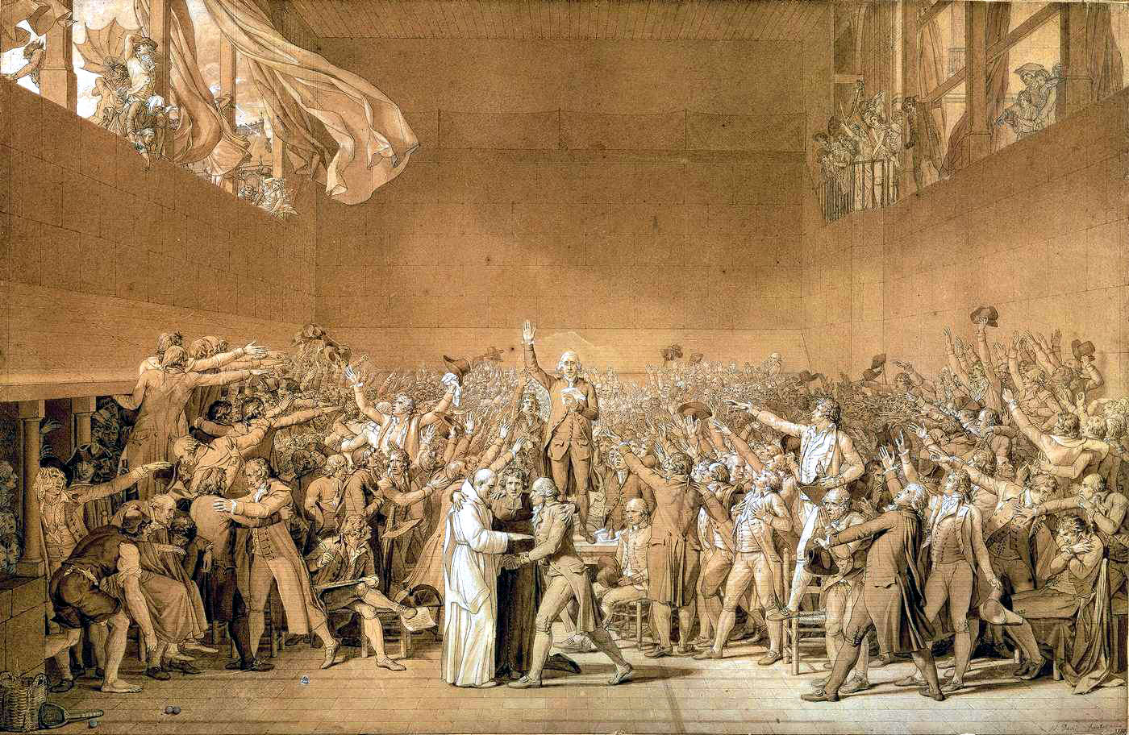Seeing the troop buildup, many of the supporters of the National Assembly worried that the King planned to use these troops to put an end to the National Assembly and to the reforms they were making.

In order to defend the National Assembly, rioters attacked the Prison of Bastille where weapons and ammunition were stored. In this battle, a number of rioters and soldiers were killed. The rioters were able to gain control of the prison and establish a new radical government in Paris.

**The Great Fear**

From Bastille, violence spread throughout the French countryside. Rumors were spread that the feudal lords had hired robbers to murder peasants. This rumor was not true, but it flamed fear that led to the peasants rising up against their local lords.

Peasants broke into manor houses, killed many of the nobles, and took possession of their properties. This wave of violence is known as the Great Fear.

The Declaration of Rights

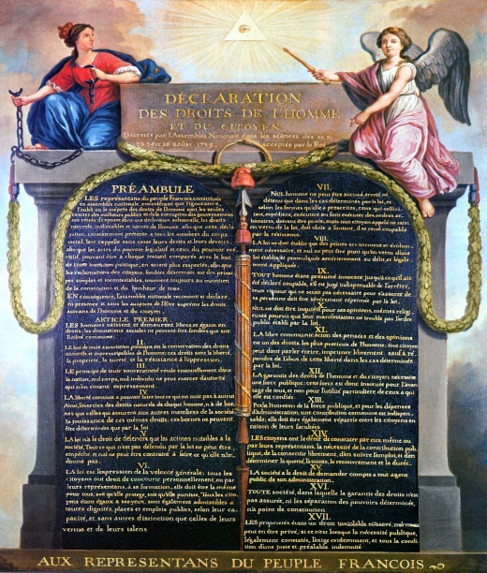As violence continued to spread throughout the countryside, members of the third estate demanded equality for all citizens of France. Members of the first and second estates held out, refusing to grant equal rights and refusing to give up the special privileges that they had enjoyed for so many centuries.

The continued escalation of violence finally convinced them that they had no choice but to give up and submit to the will of the much larger third estate. On August 4, 1789, the National Assembly passed a number of important reforms that abolished feudal dues and established taxes on members of the first and second estates.

The National Assembly then turned their attention towards creating a bill of rights for their people. This Declaration of Rights included the freedom of speech, the freedom of the press, and the freedom of religion. It also protected citizens from being falsely arrested. This Declaration of Rights remains in the French Constitution to this day.

**Royal Family Flees France**

In June of 1791, King Louis XVI, fearing for the lives of himself and his family, attempted to escape into Austria. Marie Antoinette’s brother was the emperor of Austria. They hoped that once in Austria they would be safe.

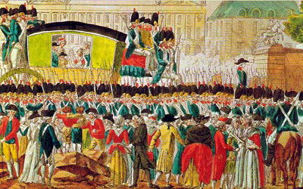

Their attempt failed, however, when they were recognized along the road by a passerby who called for soldiers to have them arrested. Returned to Paris, the king and his family had no choice but to accept any demands put upon them by the people and to remain in their home as prisoners.

A Republic is Born

From 1792 through 1795, a National Convention met in Paris to further define the new form the French Government would take. They decided to completely do away with the monarchy and establish a republic. They also granted the right to vote to all men, regardless of whether they could pay their taxes or not.

**King Louis XVI is Beheaded**

In 1792, King Louis XVI was tried before the National Convention where he was found guilty of having conspired against the liberty of the nation. In January of 1793, he was put to death by the Guillotine.

News of the death of the king was received with great joy and celebration throughout Paris and France. This was seen as a great moment and a guarantee that the revolution would now go forward.

A Revolution in Trouble

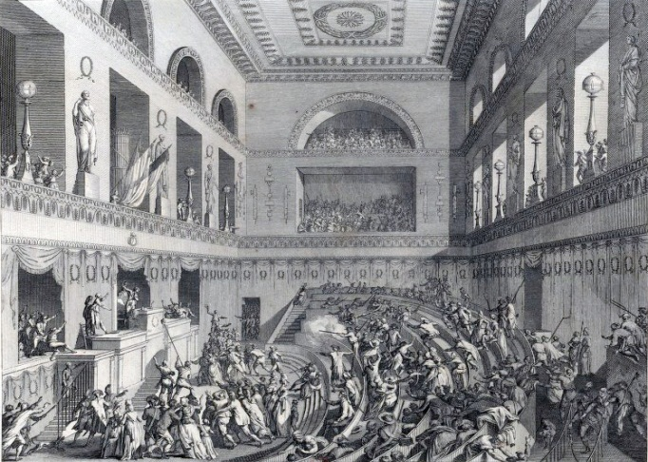Monarchs throughout Europe were concerned about the events that had taken place in France. The natural order that had existed for centuries had been disrupted. They worried that the same thing could happen in their own nations, and that their own thrones, and even their lives might be at risk.

To avoid the revolution spreading into their own nations, these monarchs joined together to fight against France. Soldiers were sent from Great Britain, the Netherlands, Spain, and Sardinia to fight against the revolutionaries in France.

This war made life very difficult in France. In order to fight these large armies, the new French government established a draft that called up all men between the ages of 18 and 45 to fight for their liberties. This draft touched off a civil war in Western France where royalists who had supported the king were angry that their sons had been forced to fight in a way that they did not support.

Within the National Convention, fierce debate and a growing divide among different political parties threatened to tear the young, fragile government apart.

The Reign of Terror

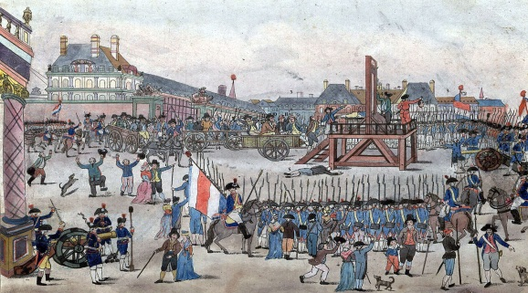Seeing the turmoil that was both within and surrounding France, the leading political party known as the Jacobins determined that they would crush any resistance within their new nation. They established neighborhood watches that were intended to find anyone who was not loyal to the new French government. These watches would turn in suspected traitors, who would often be put to death.

This period of time is known as the Reign of Terror, and lasted from July 1793 until July 1794, during which approximately 17,000 individuals were executed.